1. **ICT CONCEPTS**

**ICT Concepts: Digital Revolution. Data Processing (data vs information). Digital Devices (types). Hardware Components. The Issue of E-Waste.**

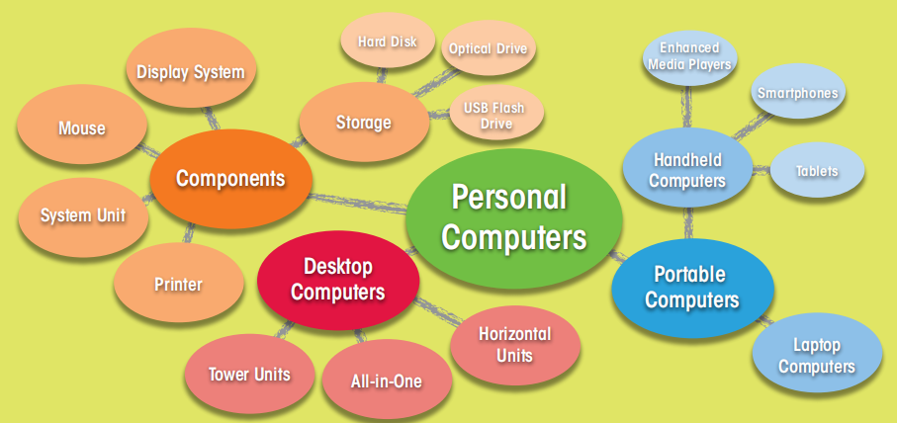

1. What are the phases of the digital revolution?
2. What’s the difference between data and information?
3. How can data be represented?
4. What is data processing? Where does most of the processing in the computer take place?
5. What are the components of a typical desktop computer system?
6. What are the basic input and output devices?
7. What is e-waste? Why is it a serious problem?
8. How to solve the e-waste problem? Do you think it is possible to solve it?

At present we live in the information age. The information is easy to access and affects many aspects of our everyday life. The information age is unique because of its underlying technology based on digital electronics. The digital revolution offers advantages, but requires adaptations.

**DIGITAL REVOLUTION:**

The digital era has evolved through four phases, beginning with big, expensive computers and progressing to the modern digital world in which small inexpensive digital devices are everywhere. **Data processing** is the computing model for the first phase of the digital revolution. In the first phase computers were huge, complex and expensive devices. They existed in limited numbers, primarily housed in big corporations and government agencies. The second stage was presented by **personal computing** which is characterized by small, standalone computers powered by **local software**. The third phase of the digital revolution materialized as computers became networked and when the Internet was opened to public use **(network computing)**. **Cloud computing** characterizes the fourth phase of the digital revolution. It provides **access** to information, applications, communications and storage over the Internet. With cloud computing you can store your data in the cloud, making it **available** no matter what computer you use.

**DATA & INFORMATION:**

To understand the nature of information we must understand another term - data. Data is any **raw facts** or observations that describe a particular phenomenon. Data becomes information when it is processed and presented in a format that people can understand and use. In the world of [computers](https://homepage.cs.uri.edu/faculty/wolfe/book/Readings/Reading01.htm), data is the input, or what you tell the computer to do or save. Information is the output, or how the computer interprets your data and shows you the requested action.

**DATA REPRESENTATION:**

Data representationrefers to the format in which data is stored, processed and transmitted. It can be represented using two methods: digital and analog. **Analog data** is represented using an **unlimited scale of values**. **Digital data** is text, numbers, sounds and video that have been converted into **binary digits** such as 0s and 1s.

**DATA PROCESSING:**

Data processing is the [collection](https://en.wikipedia.org/wiki/Data_collection) and manipulation of data to produce meaningful information. Data processing is based on an **input-processing-output cycle** which is often referred to as the IPOS cycle. In a computer most processing takes place in a component called the **central processing unit** or **CPU.** The series of instructions that tells a computer how to carry out processing tasks is referred to as a **computer program** or simply a program. These programs form the **software** that sets up a computer to do a specific task.

**HARDWARE BASICS**

Whether you are shopping for a new computer, using your trusty laptop, or troubleshooting a system glitch, it is useful to have some background about computer system components and how they work.

**A stationary desktop computer** is placed on a desk and runs on power from an electrical wall outlet. It contains **the internal nodes** of the personal computer and **peripheral devices** (input, output, and storage equipment that might be added to a computer system to enhance its functionality): system unit; keyboard; mouse; display system; hard disk drive; optical drive; removable storage; sound system; network and Internet access; printer.

**A portable computer** is a small, lightweight personal computer with input, output, storage, and processing components integrated into a single unit that runs on power supplied by an electrical outlet or a battery.

**Types of portable personal computers**: smartphone; a tablet computer; laptops or notebooks; netbooks.

Computers that operate in essentially the same way and use the same software are said to be **compatible** or having the same platform.

Basic **input devices** include: a keyboard; a mechanical or optical mouse; a scanner; a digital camera; a microphone; a trackpad (touchpad/touchscreen). Some devices require software called a device driver to set up communication between your computer and the device. An **output device** is any piece of computer hardware equipment which converts information into human readable form (monitor, headphones, speakers, printer…).

A **microprocessor** (processor, **CPU** - central processing unit) is an integrated circuit where most processing in the computer takes place. It is the largest chip on the system board.

**MEMORY**

**RAM (random access memory)** is a temporary **holding** area for data, application program instructions, and the operating system. RAM is volatile memory, which means that the information temporarily stored in the module is erased when you restart or shut down your computer. **ROM (read-only memory)** is non-volatile, which means the information is permanently stored on the chip. It stores crucial information essential to operate the system, like the program essential to boot the computer and firmware instructions.

**STORAGE DEVICES**

There are 3 main storage technologies: **magnetic** (HDD, hard disk drive), **solid state storage** or flash memory (SSD, USB flash drive) and **optical storage** technology (CD, DVD…).

**THE ISSUE OF E-WASTE**

E-waste contains a list of chemicals that are harmful to people and the environment. When electronics are mishandled during disposal, these chemicals end up in our soil, water, and air. Electronic waste is sometimes illegally exported to countries that don’t have laws on handling and disposing of it. Once there, it’s dumped. Sometimes, valuable materials are recovered, but often in unsafe working conditions. An alarming amount of e-waste is shipped to developing countries where villagers, working for pennies a day, are exposed to toxic chemicals as they attempt to reclaim resalable metals from discarded equipment.

We can solve the problem of e-waste by being more mindful about where our e-waste ends up. We can limit how much we produce and the impact it has on the environment. With the flood of e-waste growing around the world, recycling alone will not be enough. In order to reduce e-waste, manufacturers need to design electronics that are safer, and more durable, repairable and recyclable. Most importantly, this means using less toxic materials. Minimizing e-waste is important. We can re-evaluate (maybe we don’t need that new gadget) or extend the life of our electronics.